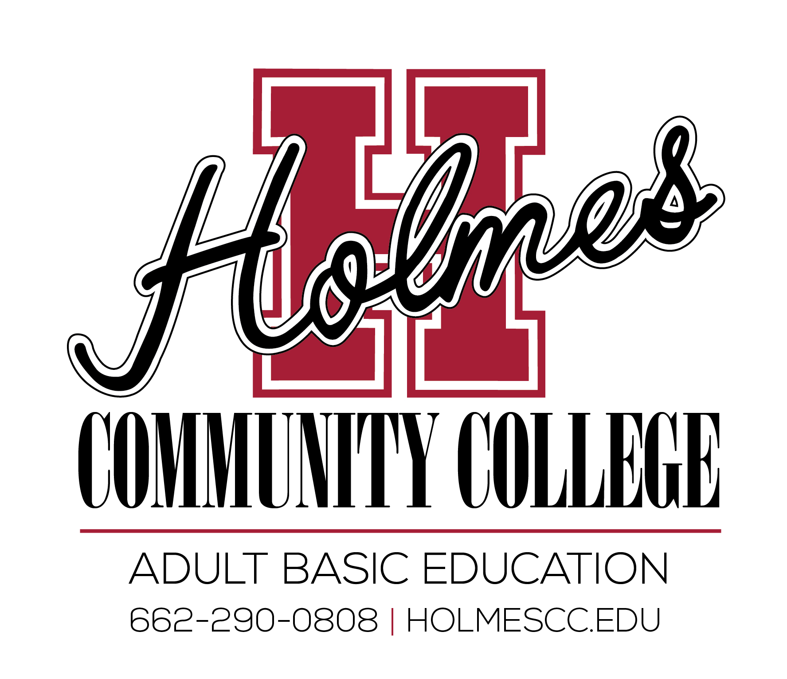
Adult Education Classes
2021-2022

Attala County | Attala Ed. Center  Kosciusko, MS | 620 West Jefferson St.  662.290.0808 | HSE/Smart Start Instructor:  Tommy Trussell  Monday-Friday 8:00 am -4:00 pm  NCRC Examiner:  Tammy Jones
MIBEST/Pathways

Monday and Wednesday 6:00 – 9:00 pm
Contact: Chelia Thompson, College and Career Navigator
601.605.3340

Eupora | The Depot  Eupora, MS | 855 Dunn Street  Eupora, MS  662.290.0808 | HSE Instructor:  Elizabeth “Jean” Shepard  Monday - Thursday 8:00 am – 12:00 pm
Madison County | Holmes Community College  Ridgeland Campus  Ridgeland, MS | 412 W. Ridgeland  601.605.3433 | HSE Day Instructor:  Jermarcus Bounds  Monday -Friday 8:00 am - 4:00 pm  HSE Night Instructor:  Jermarcus Bounds  Monday and Wednesday 5:00 -9:00 pm
Madison County | Holmes Community College  Ridgeland Campus  Ridgeland, MS | 412 W. Ridgeland  601.605.3433 | MIBEST/Pathways  Smart Start Instructor  NCRC Examiner  Monday - Thursday 8:00 am - 4:00 pm  Contact: Chelia Thompson, College and Career Navigator  601.605.3340
Yazoo County | Yazoo Teen Center  Yazoo, MS | 1222 Jackson Ave  662.746.9240 | HSE/Smart Start Instructor:  Daphne Higgins  Monday - Friday 8:00 am - 4:00 pm

Holmes Community College administers High School Equivilency Exams and The National Career Readiness Certificate at the Kosciusko and Ridgeland locations. For more information contact Tammy Jones at 662.290.0808.
(Revised 06/1/2021)

